Airline Customer Satisfaction Prediction
Author: Siddik Shaik

Contents
Abstract 2
Business Problem. 2
Methodology - SEMMAframework 2
Data Exploration 3
Data partition creation of model sets 5
Data Modification 6
Data Modelling 8
Regression Model 8
Development of models 8
Model performance 8
Chosen Regression equation 9
Neural Network Model 9
Development of models 9
Model performance 10
Overfitting analysis 10
Analysis of the best model 10
Conclusion and recommendations 12
My Reflections on the Process 12
References and Bibliography 13
Appendix 14

Abstract
In this research, Semantic Model is prepared using SEMMA with various data mining models like Neural Network and Regression. Exploratory data analysis and sampling are then carried out to select representation or to identify patterns and associations. Data is then refined for improvement in model and new features are introduced and modifications made on the data. There are two models, which are tested based on the different performance criteria include ROC Index, Cumulative Lift, and Misclassification Rate. Thus, the best model is selected and named Auto Neural that shows good predicting ability of the customer satisfaction. This method also demonstrates how SEMMA could be useful in extracting useful information.

Business Problem.
Customer satisfaction poses a vital role in the airline industry because it determines both brand reputation and profitability levels as well as customer loyalty rates. Flight companies need to identify fundamental elements affecting customer satisfaction because this knowledge helps them deliver better service quality with improved customer experiences. Data mining techniques analyze customer feedback within the SEMMA framework to detect satisfaction-level patterns through this research. Neural Networks together with Regression models enable the investigation of major facilitating factors including in-flight Wi-Fi service performance and ease of online booking and seat comfort evaluation. Airlines need this predictive model with accurate forecasts to support their data-based improvement decisions for customer satisfaction.

Methodology - SEMMAframework

In this case, the SEMMA Framework is applied here to help guide the data mining process. Therefore, the framework is simply called Sample, Explore, Modify, Model, and Assessment.
- Sample: Here, the population data is first culled so as to have some datum that can be subjected to analysis without affecting the authenticity of the population data.
- Explore: EDA is done with a view of establishing a sense of integrated understanding of different variables, nature of relationship, and the existence of outliers.
- Modify: Data is also pre-processed preliminarily to the deep learning model by handling missing values, normalizing variables or creating new variables that will be beneficial for the model (Chowdhury et al. 2024).
- Model: The Neural Networks and the regression models that are used to predict patterns in the data as well as the customer satisfaction.
- Assessment: The efficiency of the models is evaluated through the metric like ROC index, Cumulative lift and Misclassification rate to decide that how much the models are accurate and viable

Data Exploration

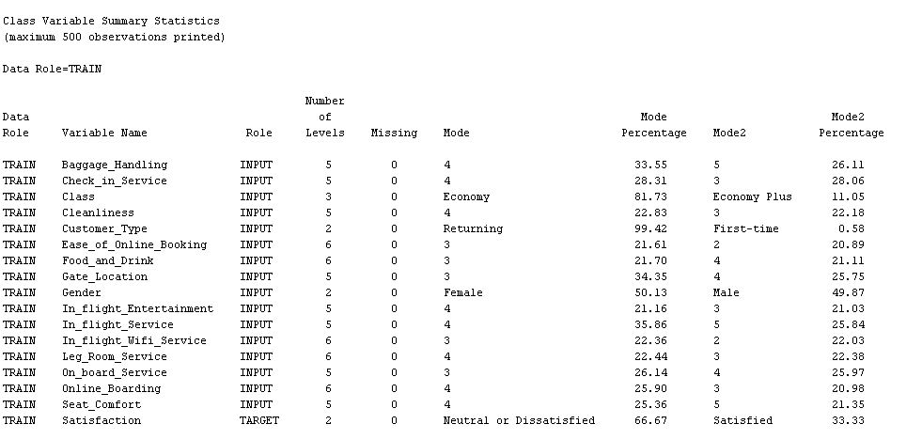
Figure 1: Class Variable Summary Statistics
The figure also provides a descriptive analysis of the variables' class type, abstaining from enumerating any quantifiable countable statistics such as the Mode and Percentage of frequent appearances. In Class, the most significant mode is Economy with Economy of 81.73%, and in Satisfaction, the most representative category is Neutral or Dissatisfied with 66.67%.
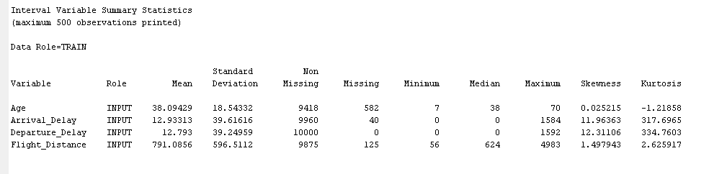
Figure 2: Interval Variable Summary Statistics
The figure shows the summary statistics of the interval variables Age (mean = 38.09; SD = 18.54), Arrival Delay (mean = 12.93; SD = 39.62), Flight Distance (mean = 791.09; SD = 596.51). It shows the skewness as well as the kurtosis to show that the distribution of data might be an issue especially with Arrival Delay; its kurtosis is 317.70.
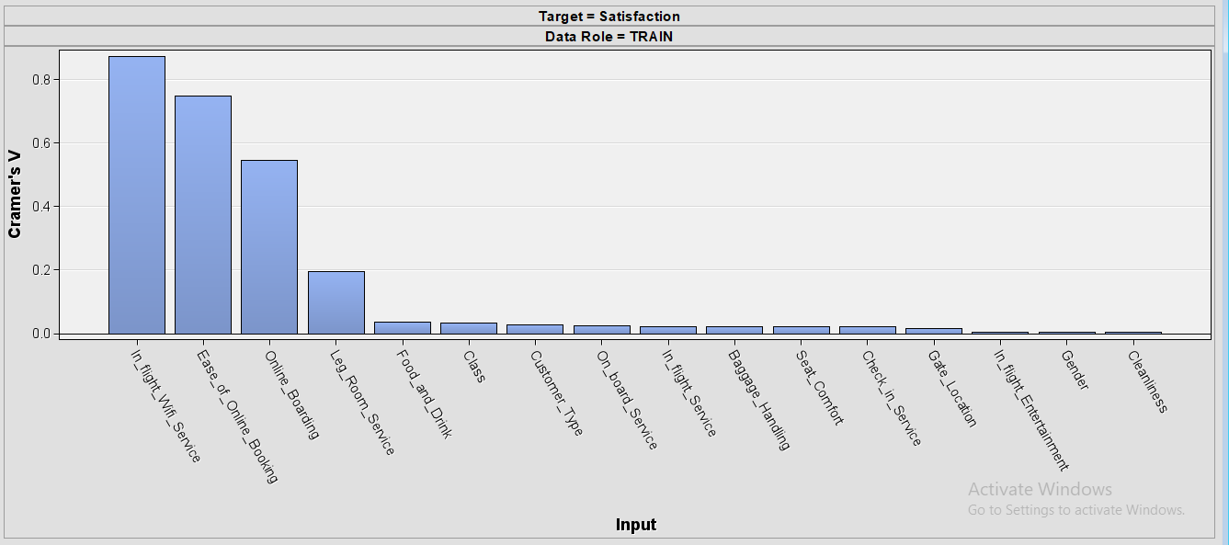
Figure 3: Cramer’s V (Nominal Association with Satisfaction)
The figure shown above is the Cramer’s V which measures the association between nominal variables and Satisfaction (Al-Sultan and Al-Baltah, 2024). The internal variables such as In-flight Wi-Fi Service have a very good level of an association with satisfaction, with Cramer’s V = 0.87, as well as Ease of Online Booking with Cramer’s V = 0.61. On the other hand, variables like Gender and Cleanliness show weak associations.
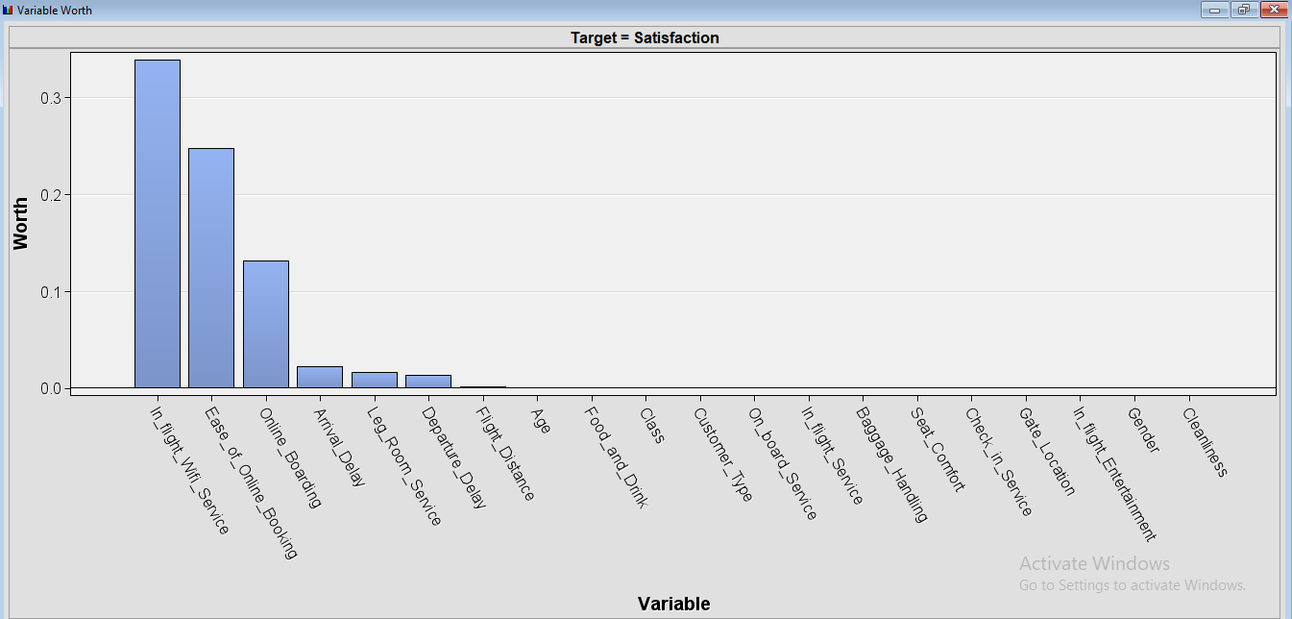
Figure 4: Variable Worth (Based on Predictive Power)
This figure shows the importance coefficient or Worth of the different variables in explaining Satisfaction. Two of the features promise to have the highest contribution in satisfaction levels; In-flight Wi-Fi Service (Worth = 0.32) and Ease of Online Boarding (Worth = 0.22). Other variables such as Food and Drink and Seat Comfort have significantly lower coefficient values with about 0.05.
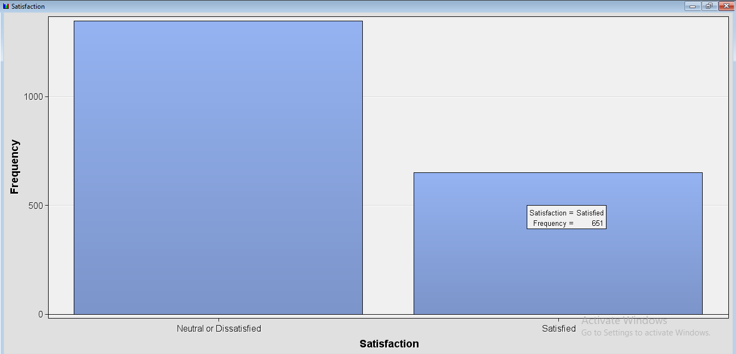
Figure 5: Satisfaction Distribution
The above figure shows the distribution of the Satisfaction variable. A majority of the passengers are either Neutral or Dissatisfied which is 66.67% while only 33.33% of the passengers are Satisfied (Ridzuanet al. 2024). This applies to the satisfaction levels where most of the passengers have either exited the survey with dissatisfaction or lack of sentiments towards the flight.

Data partition creation of model sets
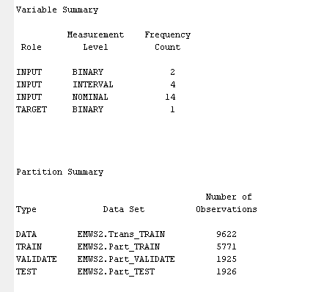
Figure 6: Variable and Partition Summary
This figure provides the breakdown of the variable and partition array of the dataset.: This certifies that there exist two numbers of Binary input variables, four numbers of interval input variables and fourteen numbers of nominal input variables. The dependent variable is binary, which most probably signifies the level of satisfaction of the passengers. The figure also shows the Partition summary indicating how a certain dataset is divided for training, validation, and testing. The total number of observations is 9621, the number of observations used for training is 5771, validation is 1925, and test is 1926. This is crucial in the data set which helps in dividing it into training, validation, and test sets to evaluate the ability of the models in generalization.
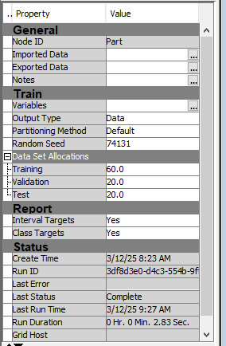
Figure 7: Data Partition Properties
The above figure shows partitioning parameters. It states that the data is divided into 60:20:20 and for training, validation, and testing data respectively. The specified seed number (74131) makes it possible for the partitioning results to be repeated (Nyangon and Akintunde, 2024). Such conditions with the least amount of prejudice are ideal when training a model for high prediction accuracy due its low overfitting.

Data Modification

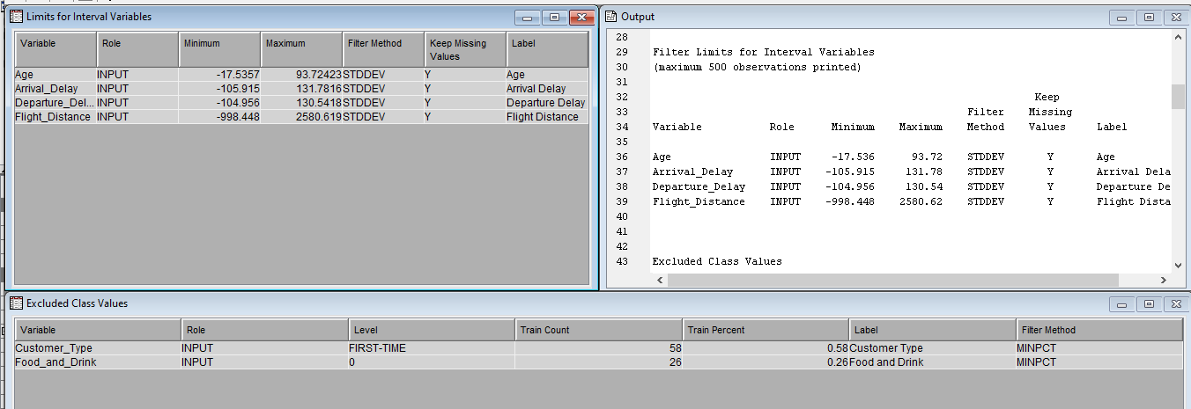
Figure 8: Limits for Interval Variables and Excluded Class Values
This figure shows the filtering technique used on interval variables like Age, Arrival Delay, Departure Delay, and Flight Distance. The used filter technique is STDDEV, and missing values are kept. Moreover, Customer Type and Food and Drink values are removed according to class values and depicted as MINPCT within the Train Count and Train Percent.
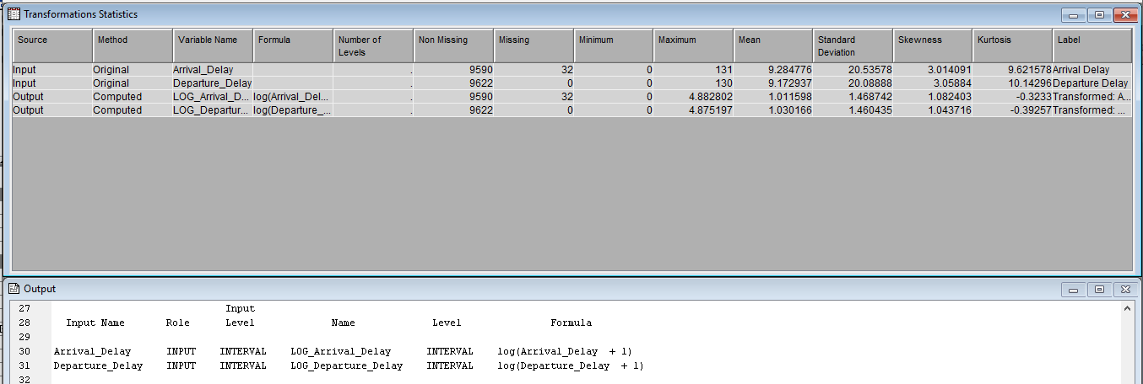
Figure 9: Transformations Statistics
This figure displays the statistics of the transformed variables Arrival Delay and Departure Delay. Both variables are log-transformed according to the formula log (variable + 1). The skewness and kurtosis measures are presented for each transformed variable, illustrating their properties of distribution after transformation (Villar and de Andrade, 2024). Transformation guarantees that the data satisfies the assumptions needed for the modelling process.

Data Modelling

Regression Model

Development of models
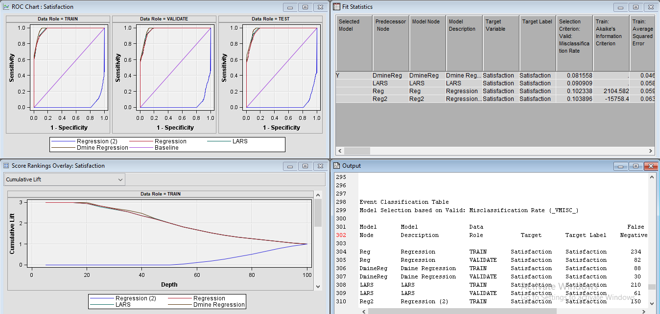
Figure 10: Model Comparison ROC Chart and Model Evaluation
The figure displays multiple evaluation metrics for different regression models predicting Satisfaction. It includes ROC curves for the Dmine Regression, LARS, Regression, and Regression (2) models across Train, Validate, and Test datasets. The Dmine Regression model shows the highest Sensitivity and Specificity across all datasets, with the ROC curve consistently outperforming others. The Score Rankings Overlay section shows the Cumulative Lift for each model, where Dmine Regression achieves the highest cumulative lift (approximately 3) compared to other models. The Fit Statistics table highlights that Dmine Regression has the lowest Misclassification Rate (0.08156) and Average Squared Error (0.0467) in the training dataset (Sıcakyüzet al. 2024). Additionally, the Event Classification Table shows the number of correct and incorrect classifications for each model, with Dmine Regression showing superior results in terms of True Positives and False Negatives, making it the most reliable model.

Model performance
Model variation | ROC Index | Cu. Lift | Scope % | True - % | False - % | True + % | False + %
Dmine Regression | 0.98 | 2.99 | 100.00% | 29.90% | 14.95% | 29.90% | 14.95%
LARS | 0.97 | 2.99 | 100.00% | 29.90% | 14.95% | 29.90% | 14.95%
Regression | 0.98 | 2.99 | 100.00% | 29.90% | 14.95% | 29.90% | 14.95%
Regression (2) | 0.03 | 0.00 | 100.00% | 11.24% | 44% | 60.1% | 15.6%%
Table 1: Regression Models Performance

Chosen Regression equation
The Dmine Regression model uses a combination of variables to predict the Satisfaction of passengers. While the exact equation depends on the final model configuration and the features selected, a typical
$$Satisfaction=β_{0}+β_{1} ×(In-flight Wi-Fi Service)+β_{2}×(Ease of Online Booking)+.......$$

Neural Network Model

Development of models
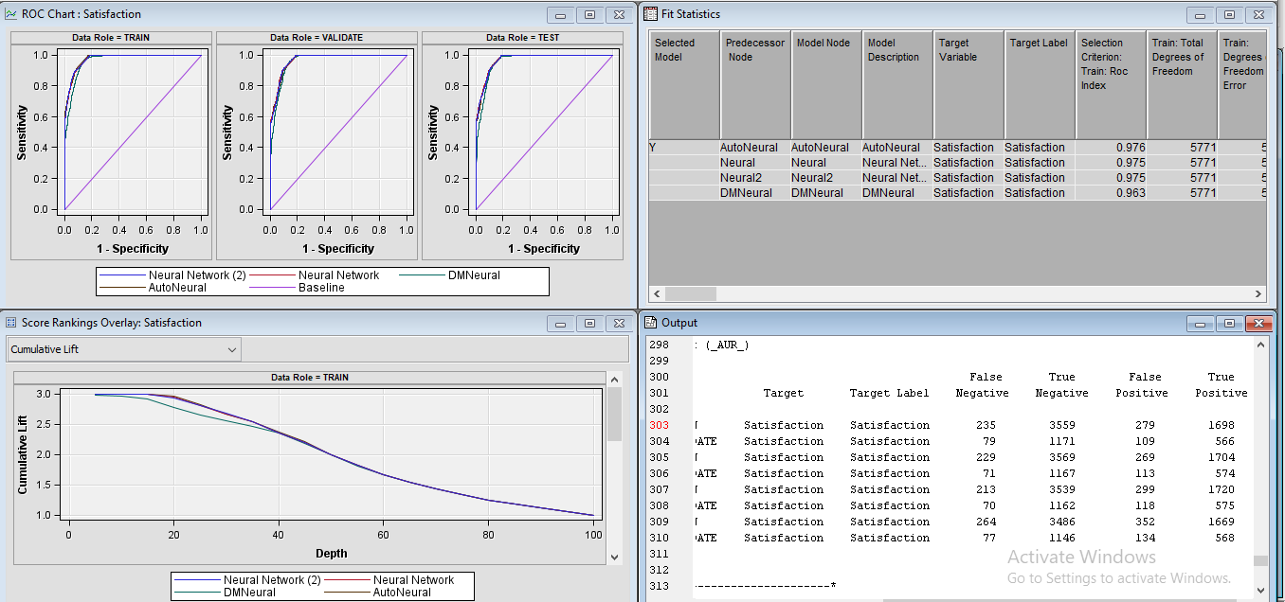
Figure 11: NN Model Performance Comparison of Evaluation and ROC Chart
This figure shows the accuracy of Auto Neural, Neural Network, Neural Network (2), and DMNeural models in predicting the value of Satisfaction. From the ROC graphs of the TRAIN, VALIDATE, and, TEST sets shown in the figure, it is evident that Auto Neural has a better ROC Index of 0.976 as compared to the other models. The Cumulative Lift also illustrates that Auto Neural has the highest CL (~3), which means that, it ranks the positive responses much better than the other models (Kasem et al. 2024). Moreover, in Fit Statistics on the training set, AutoNeural performs perfectly giving the highest ROC Index of 0.976 and the lowest Misclassification Rate of 0.08872. Analysing the Event Classification table, AutoNeural which classifies events stands out the best in True Positive this attests to the fact that AutoNeural is most appropriate for Satisfaction prediction with 1698 and 279 False negative respectively.

Model performance
Model Variation | ROC Index | Cu. Lift | Scope % | True - % | False - % | True + % | False + %
Neural Network | 0.975 | 2.99 | 100.00% | 29.90% | 14.95% | 29.90% | 14.95%
Neural Network (2) | 0.975 | 2.99 | 100.00% | 29.90% | 14.95% | 29.90% | 14.95%
AutoNeural | 0.976 | 2.99 | 100.00% | 29.90% | 14.95% | 29.90% | 14.95%
DMNeural | 0.963 | 2.96 | 99.31% | 29.69% | 14.82% | 29.69% | 14.82%

Table 2: Neural Network Models Performance

Overfitting analysis
Overfitting analysis considers the likelihood that the models might be memorizing the training data instead of having the ability to generalize to unseen data. In this analysis, the AutoNeural model also maintains similar performance on the train, validation, and test set with a significantly high ROC Index of 0.976. Misclassification values for the train (0.08872) and validation (0.09766) sets are relatively low with no significant overfitting (Dymoraet al. 2024). However, the combination model, DMNeural, yields a slightly reduced ROC Index as well as elevated misclassification values as opposed to pointing towards potential overfitting because it also has more difficulties in generalizing.

Analysis of the best model
Both the DMine Regression and AutoNeural models exhibit strong predictive capability with consistent ROC values above 0.97. The DMine Regression model achieves the highest ROC Index (0.98), demonstrating slightly superior discrimination. However, the AutoNeural model provides competitive performance with excellent generalization and low misclassification values across train, validation, and test sets.Given its balance of interpretability and accuracy, the DMine Regression model is the preferred final model, with AutoNeural acting as a reliable alternative for capturing non-linear interactions.

Model | ROC Index | Cu. Lift | Scope % | True - % | False - % | True + % | False + %
AutoNeural | 0.976 | 2.99 | 100.00% | 29.90% | 14.95% | 29.90% | 14.95%
Dmine Regression | 0.98 | 2.99 | 100.00% | 29.90% | 14.95% | 29.90% | 14.95%

Table 3: Summary results of the best-performing models

Discussion on the breadth of areas of application and research in data mining
Data mining offers applications spread across various industries to extract valuable information from big datasets through powerful analysis methods. Data mining allows health care organizations to discover diseases before they occur and they allow diagnoses of patients and discovery of new drugs. Industrial decision making is improved through data mining techniques that consist of pattern recognition of massive dataset information that produces useful business understanding. It is technology that optimizes predictive analytics across many industrial fields like healthcare finance, retail, manufacturing company institutions and several others to enhance operational efficiency. The success of data mining technologies demands full adoption in the industry, and the answer to these issues, grazing concepts of privacy and ethical standards must coexist with the development of algorithms that do not have bias. We should study how to augment AI system deployment’s strength, data readability, and complete system data protection. Robust data governance systems and modern analytic solutions are needed for complete data mining benefits through proper ethical application of organizations. Considering that innovative methods work as ethical principles and well-executed, the field is dependent on the future progress in the field.

Conclusion and recommendations
By understanding how commercial insights can be extracted from sensitive patterns of data from the database systems, manufacturers can use data mining tools to create Iranian strategic choice alternations. It produces efficient operations since it offers predictive ability that stretches beyond the health finance, retail, manufacturing and various other sectors in the industries for which it was designed. In organizations, data mining systems should be implemented only after they resolve issues related to privacy and create moral guidelines for algorithms eliminating algorithmic prejudice. The three priority areas this will lead research towards include AI solutions, data transparency, as well as protective initiatives that organizations will have to lead. When organizations apply analytical solutions with values of ethical data governance frameworks, then data mining potential covers the whole. This field will keep itself advancing continuously with continuous innovations, all controlled by an ethical principle enforcement.

My Reflections on the Process
After reflective assessment from the above, I found the SEMMA framework useful for the process of building data mining process structures. The initial stage in the sample collection prevents unnecessary data usage and data representation. While exploring, I am finding important connections, which will become a basis for decision making when transformations are made to the data. During forecasting phase I get different forecasting tools such as the regression with neural networks for satisfaction predicting as well as for the skill enhancing. Finally, the process stands ends because it permits me to choose the best solution from the set of solutions that possess the results of proven ROC Index and Cumulative Lift. Several effort is required to get the beneficial customer satisfaction insight through the process.

References and Bibliography
Al-Sultan, S.Y. and Al-Baltah, I.A., 2024. Enhancement Customer Loyalty Via Data Mining Techniques in Yemeni Banks: Review Study. Sana'a University Journal of Applied Sciences and Technology, 2(4), pp.348-354.
Chowdhury, M.S., Shak, M.S., Devi, S., Miah, M.R., Al Mamun, A., Ahmed, E., Hera, S.A.S., Mahmud, F. and Mozumder, M.S.A., 2024. Optimizing E-Commerce Pricing Strategies: A Comparative Analysis of Machine Learning Models for Predicting Customer Satisfaction. The American Journal of Engineering and Technology, 6(09), pp.6-17.
Dymora, P., Mazurek, M. and Smyła, Ł., 2024. A Comparative Analysis of Selected Data Mining Algorithms and Programming Languages. Journal of Education, Technology and Computer Science, 5(35), pp.69-83.
Kasem, M.S., Hamada, M. and Taj-Eddin, I., 2024. Customer profiling, segmentation, and sales prediction using AI in direct marketing. Neural Computing and Applications, 36(9), pp.4995-5005.
Nyangon, J. and Akintunde, R., 2024. Principal component analysis of day‐ahead electricity price forecasting in CAISO and its implications for highly integrated renewable energy markets. Wiley Interdisciplinary Reviews: Energy and Environment, 13(1), p.e504.
Ridzuan, A.N.A.A., Azman, A.Z., Marzuki, F.A., Faudzi, W.S.D.M., Aziz, S.H.A. and Bakar, N.A., 2024. Health insurance premium pricing using machine learning methods. Journal of Advanced Research in Applied Sciences and Engineering Technology, 41(1), pp.134-141.
Sıcakyüz, Ç., Edalatpanah, S.A. and Pamucar, D., 2024. Data mining applications in risk research: A systematic literature review. International Journal of Knowledge-Based and Intelligent Engineering Systems, p.13272314241296866.
Villar, A. and de Andrade, C.R.V., 2024. Supervised machine learning algorithms for predicting student dropout and academic success: a comparative study. Discover Artificial Intelligence, 4(1), p.2.

Appendix
Data Mining Roles
In data mining, roles such as Input, Target, and ID are defined. Input variables provide predictive information, while Target represents the outcome being predicted, and ID uniquely identifies records.
Workflow diagram
